Environment material management  process |  |  |  |  |  |  |  |  |  | 
Document no |  |  | RS-EP-01 |  |  |  |  | Written by |  |  |  | Mark.Kim
Rev no |  |  | 001
Rev. date | 2022.10.26 |  |  |  |  |  |  | Department |  |  |  | QM
Revised contents |  |  |  |  |  | Drift |  |  | Review |  |  |  | Approval
 |  |  |  |  |  | / |  |  | / |  |  |  | /
Revised Items | AS IS |  |  |  |  | TO BE
Agreement | QM | R&D
 | Opinion:

[Revision history]
Revision history summary |  |  | RS-EP-01
 |  |  | Revision | 001
 |  |  | Confidential | G1
Rev. no | Rev. date | Simple description of changed contents | Author | Post
001 | 2022.10.26 | Newly established. | Mark.Kim | QM

1. Purpose and scope
This process defines the items and procedures to be managed in order to comply with international hazardous substances environment standards for product developed and mass produced by our company.

2. Apply scope
Raw material & packing material that is used to product’s manufacturing.

3. Definition of terms
3.1 hazardous substances
Substance that bad affect the global environment among substances contained or used in products and packing materials.
3.2 Controlled material
Substances that are prohibited from being contained or used in products and packing material according to domestic and global laws and regulations among hazardous substances.
3.3 Raw material
All of materials to composing products & packing.
3.4 Prohibited substance content analysis result (Usually ICP analysis result)
As the quantitative and qualitative analysis data of the content of hazardous substances analyzed through the analysis method with certain validity, it is usually ICP analysis is a globally valid method.

4. Relevant form
N/A

5. Responsibility and authority
5.1 Subcontractors or suppliers
-. Subcontractors conduct preliminary environmental evaluation of raw-materials and packing materials applied to new product development. To conduct a preliminary review of the materials to ensure that environmentally hazardous substances and regulated substances are within the permitted range should be carried out
-. The results of the evaluation of environmentally regulated substances for the relevant materials must be submitted to the company upon completion of development, and the results of the evaluation of environmentally regulated substances must be recognized during the internationally recognized certification period. The results of experiments conducted by non-accredited organizations can be used as reference data, but cannot be used as data for certification. The results of experiments conducted by institutions can be used as reference data, but cannot be used as data for certification.
-. After the completion of development, the monitoring of environmentally hazardous substances in the mass production process must be carried out, and the environment of the raw and subsidiary materials. The evaluation must be submitted to the company under revision management on a one-year cycle.
5.2 Quality management division
-. In the process of developing new products, our Quality Assurance Office has the duty and responsibility to check whether the raw and subsidiary materials developed by outsourced companies meet the international environmental regulatory substance management standards.
-. In the process of mass production, monitoring of environmentally controlled substances is secured from an outsourced company once/year for each raw and subsidiary material concerned.
-. If there is a change in the raw material, it is necessary to proceed with the qualification of whether the changed material contains harmful substances.
-. If necessary, request an external authorized agency to conduct analysis of environmentally hazardous substances (Cd, Hg, Pb, Cr+6, PBBS, PBDES) and outsource make sure to verify the partner data.

6. Process map

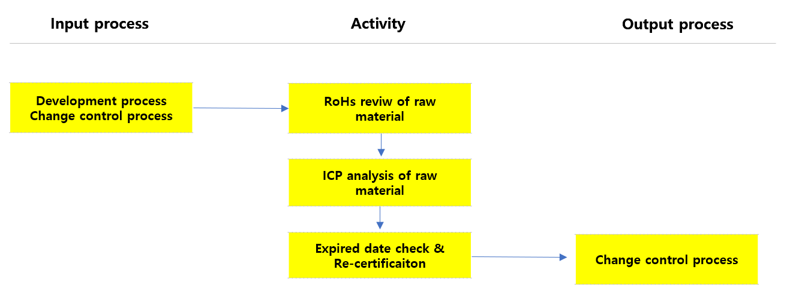
7. Process description
In  process | Input | Activity | Output | Out  process | Freq. | Review | Approval
-. Development process  -. Change control process | Product specification | In the development department, the BOM of the subcontractor  When selecting, whether it contains environmentally harmful substances  Prior review and compliance with international environmental regulations  Check in advance whether there is a violation. | -. Select BOM  -. Changed BOM | - | At event | Charge person | CTO  CQO
- | -. Select BOM  -. Changed BOM | -. The subcontractor conducts ICP analysis of the selected BOM.  Environmentally hazardous substances within the standard  Take a cognitive test and submit it to us.  -. If the BOM needs to be changed, the subcontractor reports to the company in advance and conducts ICP analysis to guarantee the presence of hazardous substances. | -. PCN  -. ICP Analysis result | -. Change control  process | At event | Charge person | CQO
 | ICP analysis report | During mass production, ICP for each BOM  The report manages Expired data and  Check if it is within the validity period  After the expiration date,  Request to renew your ICP report to keep it up to date  should keep | -. Revised ICP  Analysis report | - | At event | Chare person | CQO

8. RoHS(Restriction of Hazardous Substance) Critiera
8.1 RoHS
Classification | Materials | CAS NO | Permission (PPM) | Criteria
RoHS | Cd | Cadmium | 7440-43-9 | 5 ↓
 | Pb | Lead | 7439-92-1 | 100 ↓
 | Hg | Mercury | 7439-97-9 | 100 ↓
 | Cr=6 | Chromium 6+ | 18540-29-9 | 100 ↓
 | PBBs | PBBs | 13654-09-6 | 100 ↓
 | PBDEs | PBDEs | 1163-19-5 | 100 ↓

8.2 Restriction material
Classification | Material | CAS NO | PPM
Restriction  material | Amides, amines | 445409-27-8 | 1000
 | Antimony and its compounds | 7440-36-0 | 1000
 | Arsenic and its compounds | 7440-38-2 | 0
 | Asbestos and its compounds | 1332-21-4 | 0
 | Azo dyes | 495-48-7 | 30
 | Beryllum and its compounds | 7440-41-7 | 200
 | Bismuth and its compounds | - | 1000
 | Chlorofluorocarbons | 75-69-4 | 0
 | Chloro parffins | 63449-39-8 | 1000
 | Ethlene Glycol Monoethyl Ether | 110-80-5 | 5
 | Ethylene Glycol Monomethyl Ether | 109-86-4 | 5
 | Formaldehydes | - | 0.1
 | Halons(Ozone Depleting Chemicals) | 353-59-3 | 0
 | Hydrochlorofluorocarbons  (Ozone Depleting Chemicals) | 75-45-6 | 0
 | Hydrochlorofluoro carbons | - | 1000
 | Halogendated dioxins and furans | - | 0
 | Nikel and its compounds | 7440-02-0 | 0
 | Organo Tin and its compounds | 7049-94-2 | 0
 | Phthalates | - | 1000
 | Polychlorindatd biphenyls(PCBs) | 1336-36-3 | 0
 | Polychlorinated naphthanlenes(PCNs) | - | 0
 | Polychloroterphenyls(PCTs) | 61788-33-8 | 0
 | Polyvinyl choloride(PVC) | 9002-86-2 | 0
 | Selenium and its compounds | 7782-49-2 | 1000
 | Short chain chlorinated paraffins(SCCPs) | - | 0
8.2 Managing material
